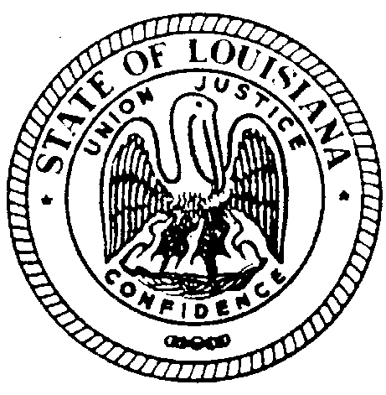

State of Louisiana
The Louisiana State Board for Hearing Aid Dealers
Attn: Dina E. Zeevi 2237 N. Hullen St. Ste. 203 Metairie, LA 70001
Ph: (504)655-0383 E-mail – labhad@la.gov

EMBASSY SUITES 4914 CONSTITUTION AVE BATON ROUGE, LA 70808 CAUCAS ROOM

Friday January 20, 2023

Minutes of Meeting

The Louisiana Board for Hearing Aid Dealers Meeting was called to order at 1:3pm on
January 20, 2023 held at the Embassy Suites Congress Room Baton Rouge, LA by Chairman Jeremy Stroud.

- CALL TO ORDER – Roll Call-Establish Quorum
Those present were Alisea Cormier, Bryan Stinson, Jeremy Stroud, Emily Fonte, Andrea Heard-Rowe, & Jason Shevchuk. Quorum established. Dina Zeevi, the Board’s Administrative Secretary was present to take the minutes of the meeting.

Public Comments- none

- APPROVAL OF AGENDA
Andrea Heard-Rowe made a motion to accept the meeting agenda. Motion 2nd. Approved Unanimously.

- READING/APPROVAL OF MINUTES – July 29, 2022
Minutes of the meeting were presented to the Board in form of an advanced email. Bryan Stinson made a motion to dismiss the reading of the minutes and accept the minutes; the motion was seconded. All in favor, approved unanimously.

- SECRETARY/TREASURER’S REPORT
- Review Budget YTD
Presented by Emily Fonte. No issues with Report.

- ADMINISTRATIVE SECRETARY’S REPORT
- Licensed HAD Renewals
- TTP Issued
- Cert. of Endorsement Issued
- Hearing Exam Applicants- Pass/Fail
- Corp. Form Renewals
Report tabled until next meeting.

- COMMITTEE REPORTS
- Ethics Committee-Bryan Stinson
EXECUTIVE SESSION
Complaint #118 12/21
Complaint #120 9/22
Andrea Heard-Rowe made a motion to move into Executive Session. Motion was seconded. All in favor, approved unanimously. Executive Session start time: 1:37pm. Emily Fonte made a motion to exit Executive Session and return to Regular meeting. Motion was seconded. All in favor, approved unanimously. Executive Session ended 2:17pm
Complaint #118 12/21 ongoing court review
Complaint #120 9/22 Emily Fonte made a motion to accept the recommendation of the Ethics Committee to dismiss as no statute violations were found. Motion was seconded. All in favor, unanimously approved.

Break 2:18pm-2:28pm

- Examination Committee-Bryan Stinson
2 Practical Examinations- Passed
1 Written Examination- Failed

- Legislative Committee- Jeremy Stroud
Statutes regarding Corporate Form and ‘Elderly Consumer’ have been submitted to state for review.

- UNFINISHED BUSINESS
none

- NEW BUSINESS
- All CEs Online
Emily Fonte made a motion to leave the statute language as it is. Motion was seconded. All in favor, approved unanimously.

- ELECTION OF OFFICERS
Ethics Committee: Alisea Cormier
Bryan Stinson made a motion to dissolve the Examination Committee. Motion was seconded. All in favor, approved unanimously.
Legislative Committee: Jeremy Stroud
Chairman: Jeremy Stroud
Secretary/Treasurer: Emily Fonte

DATE AND LOCATION OF NEXT 2023 MEETING/PRACTICAL EXAMINATION
Next meeting scheduled Saturday June 3, 2023 time TBD @ Metairie Marriott
Next Practical Examination scheduled Saturday June 3, 2023 from 9:00am-12:00noon @ Metairie Marriott

ADJOURNMENT
Jason Shevchuk made a motion to adjourn. Motion was seconded. All in favor, unanimously approved. Meeting adjourned @ 3:08pm

